

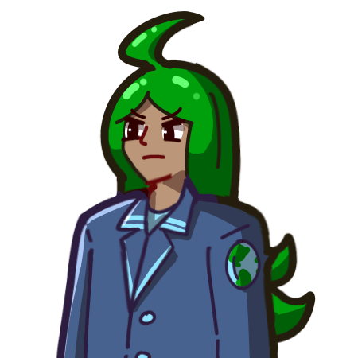











The NYC Otaku Choir
Summer 2026

Soprano
Amanda
Felicity Audet
Elaine C.
Sophia Chan
Arya Chandra
Melanie Chin
Heather Huang
Jasmine Jenkins
Joanna Ju
Silvia Martinez
Ashley Mendez
Sophie Mori
Miffy Musngi
Inez Nelson
Delaney R. Page
eris prado
Midori Sano
Angi Suwoto
Cherry Xu
Annie Y

Alto
Rahanna Brown
Kelly Burrus
Harmony Chau
Morgani Aiyana Elam
Mia Harada
Diana Hernandez
Illy “Allison” Huang
Kyla Hunter
Jibi Jacob
Erica Klein-Meisenhelter
Mente
Yulin Ni
Onyx
Ariana Osmanzai
Jalisha Paz
Eiji Ren
Ash Toner
Amanda Waldron
Alice Q Wong

Tenor
Connor "Bear" Barre
Jiahao Chen
Ethan Ferrall
Johnathan Gibbs
James Huang
Frederick Li
Nathan Li
Abraham Rogers Lopez
Shiana M
Patty Mahaney
Anthony Merolla
Jourdan Ooi
Nina Pankova
Joshua Pyram
Christopher Smith
Justin Sun
Randolph Tan
Ivan Wang
Erin-Marquise Watson

Bass
Injung Ahn
Chomp Martinez Cuevas
Quinn Ferguson
Pablo Giraldo
Sadinah Gueye
Pierce Lai
Richard Lu
Andrew McGowan
Joel Verez Mora
Dante Rose
Evan Rosson
sebastián villamizar santamaría
Geoffrey Shlapak
Michael Steigman
Ko Tanaka
Jason Wang

Accompanist  James Brandfonbrener | Co-Conductors  Joanna Ju  Ko Tanaka | Artistic Director  Johnathan Gibbs

Director of Operations
Mente
Volunteers
Calise Jin  Gordon Wang  Natt Hong  Kalif Terrell Mayers | Quyen Hoang  Junming Qiu  Yanne Veloz  Judy Wu | Steven Liu  Jibi J  Samuel Calto

Thank you for joining us tonight at The DiMenna Center for Classical Music as we present Otaku Oratorio 2: I Set Out to Save the World, but It Turns Out the World’s Greatest Threat Is a Kid Who Calls Me Mom. The Otaku Choir has been working hard to make tonight’s show a reality. We’ve leveled up since last year, too! This year, we are introducing hand-drawn sprites, animated within the Ren’Py engine. We have also added sound cues and effects, much different than last year, which only featured background music. Finally, our story has evolved from a narrated script to a full-fledged and voice acted spectacle. Last year we premiered the Otaku Oratorio with an Isekai story. This year we present a Space Saga. It is our hope that you will return next year as we present our third Otaku Oratorio that approaches the Magical Girl genre. Finally, we would like to let you know that no generative AI was used to create or produce this show. Thank you, again, for being here with us.

Act 1  Fumetsu no Hero  Masaaki Endo  Arr. Ko Tanaka  Butter-Fly  Hidenori Chiwata  Arr. Richard Lu  Hana Ni Natte  Shingo Anami  Arr. Kohsuke Negishi  Moonlight Densetsu  Tetsuya Komoro  Arr. Yulin Ni  Shanghai Tan  Joseph Koo  Arr. Cherie Chai  Lillium  Kayo Konishi & Yukio Kondo  Arr. Anthony Merolla  Weight of the World  Keiichi Okabe  Arr. Sophia Chan  Ragnarok  Masashi Hamauzu  Arr. MostlyMiSinging | Act 2  The Final Day  Masayoshi Soken  Arr. Andrew McGowan & Geoffery Shaplak  Silhouette  Maguro Taniguchi  Arr. Ko Tanaka  Soto  Hakushi Hasegawa  Arr. Ko Tanaka  Floating Moon on the Water  Wei-Pin Chen  Arr. Eric Liu  Baka Mitai  Mitsuharu Fukuyama  Arr. Yulin Ni  Destati  Yoko Shimomura  Arr. Joel Scianna  Super Smash Brothers Brawl Opening  Nobuo Uematsu  Arr. ZaneChihuahua  Welcome to the New World  Tadashi Ikegami  Arr. Ethan Ferrall
OTAKU ORATORIO 2
I Set Out to Save the World, but It Turns Out the World’s Greatest Threat Is a Kid Who Calls Me Mom.

WRITER  Johnathan Gibbs | DIRECTOR  Danny | ASSISTANT DIRECTOR  Silvia
USAGI KITADANI  Sophia Chan | GEORGE SANDERS  Chomp | TAKESHI WILLIAMSON  Geoffrey Shlapak
THE CHILD, COMPUTER VOICE  Jalisha Paz | KOHEI KITADANI  Erin-Marquise Watson | LINDA KITADANI  Rahanna
GUNNER CHIEF  Allison “Illy” Huang | PROFESSOR KELISHA  Ashley Foster | NEWS REPORTER #1 • GOSSIPPING STUDENT #1 • TRAIN SECURITY GUARD • FIRST OFFICER  Felicity Audet
NAVIGATION CHIEF • NEWS REPORTER #3 • GOSSIPING STUDENT #3  Eiji Ren | QUEEN ELIZABETH NEWARK  Ariana Osmanzai | BARTHOLEMEW BARTHANDELUS  Connor “Bear” Barre
PROFESSOR WELLINGTON  Delaney R. Page | ELITE GENERAL ROBERT HUXTABLE  Pablo Giraldo | SABIK THE GREAT RESETTER  Nina Pankova
BGM MUSIC SUPERVISOR  Nathan Li | BGM ASSISTANT SUPERVISOR  Abraham Lopez | SOUND EFFECT SUPERVISORS  Ko Tanaka • Nathan Li
VISUAL NOVEL OPERATOR  Kyle Navarro | VISUAL NOVEL ENGINEER / ANIMATOR  Evan Rosson | LOGO DESIGN  AJ
MANGA PANELIST  Alice | EYECATCHES  Miffy, AJ | SCENE ARTIST  Shiana, Elaine, Connor “Bear” Barre, Miffy
CHARACTER SPRITE ARTIST  Pierce | SOUND MIXING  Nadeem | MECH SPRITE ARTIST  AJ, Shiana, Elaine, Pierce
COSTUMING
Ariana Osmanzai • Erica Klein-Meisenhelter
No generative AI was used to create this show.

